**Experiment -3.1**

**Student Name:**Parikshit sharma **UID:**19BCS4520

**Branch:** CSE **Section/Group** IOT/A

**Semester:** 4  **Date of Performance:**15/04/2021

**Subject Name:** PBIJ **Subject Code:CSP-**296

**1. Aim/Overview of the practical:**

Create a console based application using Java as frontend and Oracle as backend for their Inventory and Sales maintenance.

**2. Task to be done:**

**Java as frontend and Oracle as backend for their Inventory and Sales maintenance.**

**3. Apparatus(For applied/experimental sciences/materials based labs):**

NetBeans

**4. Algorithm/Flowchart (For programming based labs):**

Step 1 create a database

Step 2 connect the MySQL to it.

Step 3 Add id as root and password

Step 4 add the database URL to it

Step 5 exit

**5. Theme/Interests definition( For creative domains):**

NetBeans IDE comes bundled with support for the MySQL RDBMS. Before you can access the MySQL Database Server in NetBeans IDE, you must configure the MySQL Server properties.

1. Right-click the Databases node in the Services window and choose Register MySQL Server to open the MySQL Server Properties dialog box

2 Confirm that the server hostname and port are correct.

Notice that the IDE enters localhost as the default server hostname and 3306 as the default server port number.

3 Enter the Administrator user name (if not displayed).

**6. Steps for experiment/practical:**

import java.sql.*;

import java.util.Scanner;

public class MySql {

public static void main(String[] args) {

try{

String name=null;

String pname=null;

int quantity;

Scanner sc=new Scanner(System.in);

System.out.print("Enter the Customer name");

name=sc.next();

System.out.print("Enter the product name");

pname=sc.next();

System.out.print("Enter the quanity");

quantity=sc.nextInt();

Class.forName("com.mysql.jdbc.Driver");

Connection con=DriverManager.getConnection("jdbc:mysql://localhost:3306/parikshit?zeroDateTimeBehavior=convertToNull","root","");

Statement stmt=con.createStatement();

PreparedStatement ps=con.prepareStatement("insert into sales values(?,?,?)");

ps.setString(1,name);

ps.setString(2,pname);

ps.setInt(3,quantity);

ps.executeUpdate();

System.out.println("Successfully");

ResultSet rs=stmt.executeQuery("select * from sales");

while(rs.next())

System.out.println(rs.getString(1)+" "+rs.getString(2)+" "+rs.getInt(3));

System.out.println("Successfully");

con.close();

}catch(Exception e){ System.out.println(e);}

}

}

**7. Observations/Discussions(For applied/experimental sciences/materials based labs):**

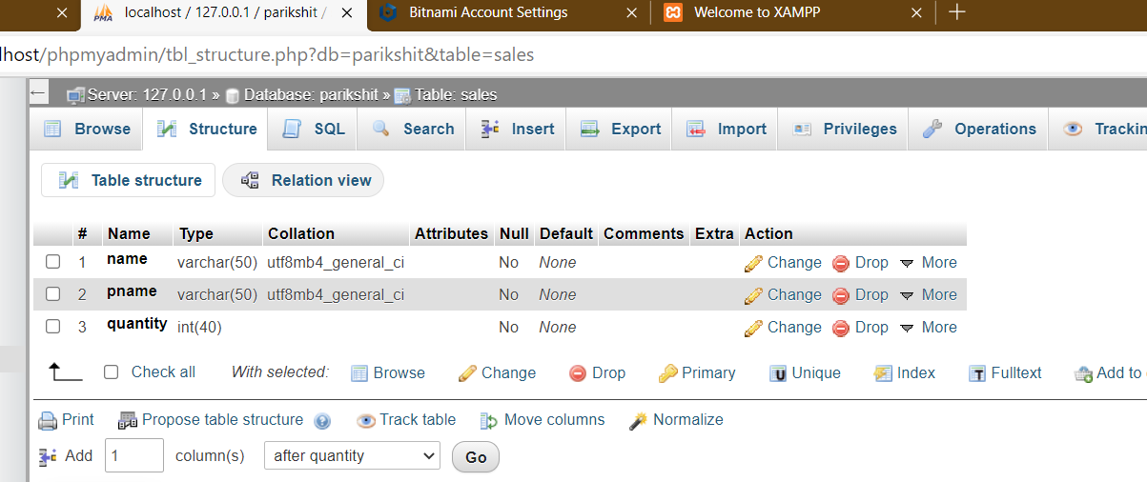

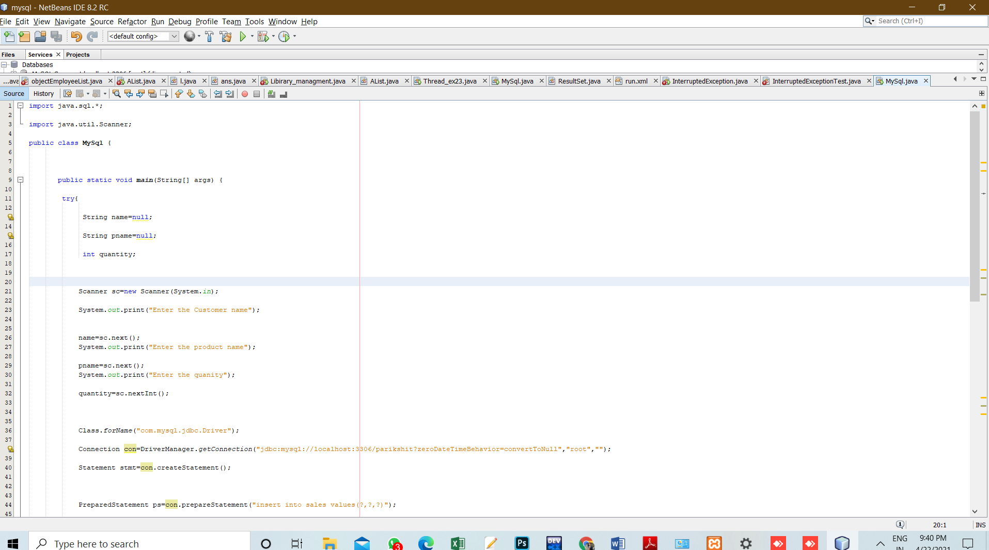

**8. Percentage error (if any or applicable):**

no

**9. Calculations/ Chemical Reactions / Theorems /Formulas used etc :**

no

**10. Result/Output/Writing Summary:**

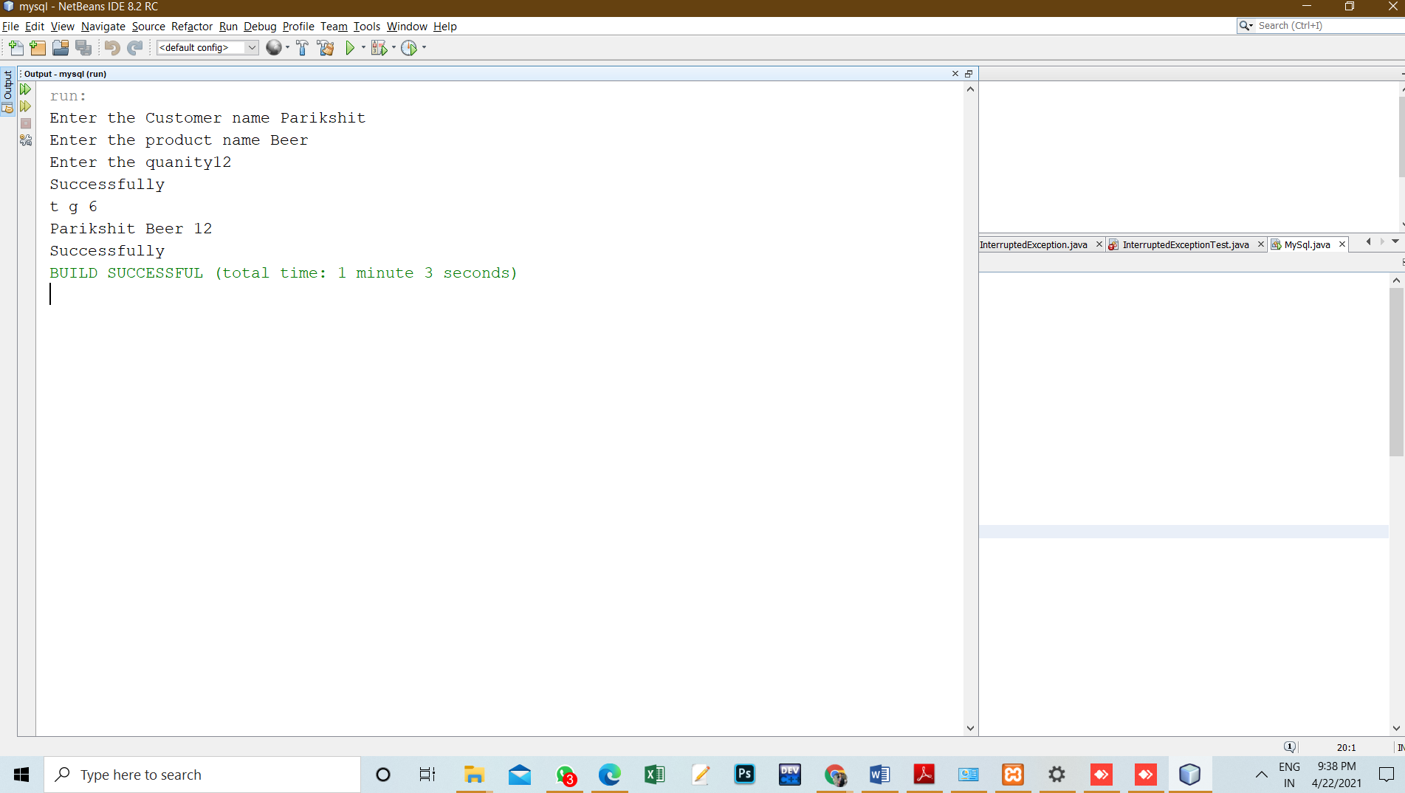

**11. Graphs (If Any): Image /Soft copy of graph paper to be attached here**

no

**Learning outcomes (What I have learnt):**

1. Learned about the libraries of My SQL in java.

2. Establishing a connection between Java and SQL.

3. Executing SQL commands through Java.

4. Finding the errors in syntax.

5. Finding the errors in the connection statement.

**Evaluation Grid (To be created as per the SOP and Assessment guidelines by the faculty):**

|  |  |  |  |
| --- | --- | --- | --- |
| Sr. No. | Parameters | Marks Obtained | Maximum Marks |
| 1. |  |  |  |
| 2. |  |  |  |
| 3. |  |  |  |
|  |  |  |  |